Recruitment
Hardcoded or limited nationality filter but in form there is list of nationality
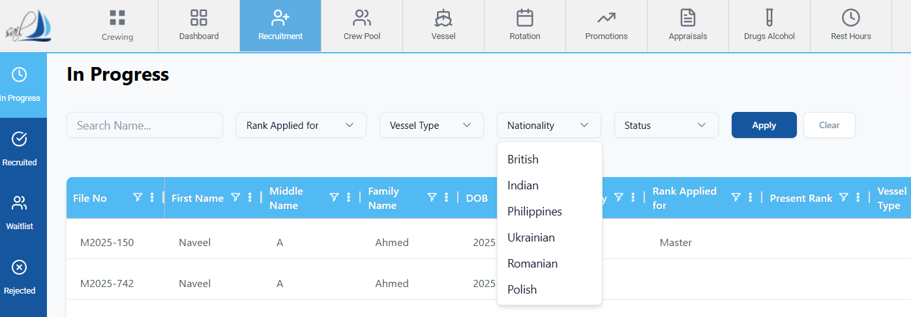

Not working
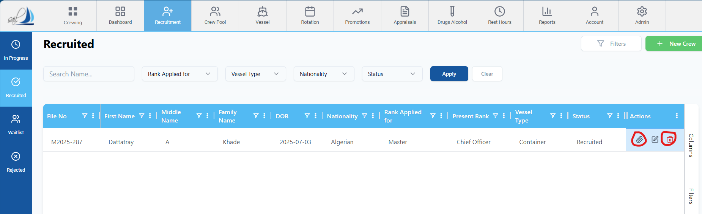
company processing
comments not saving and B7 section also not saving data ,
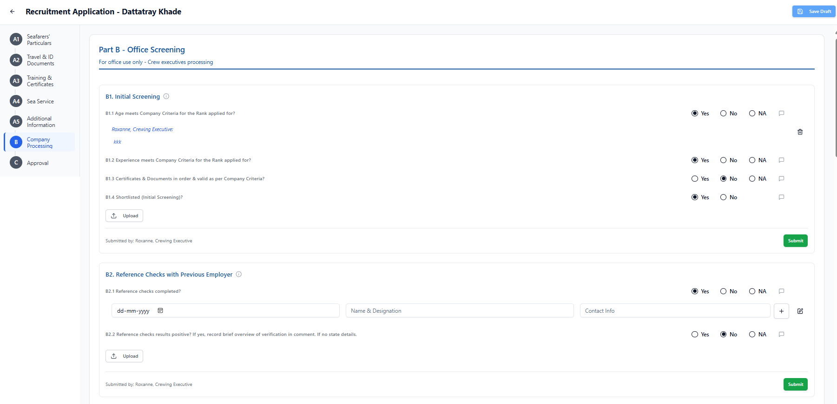

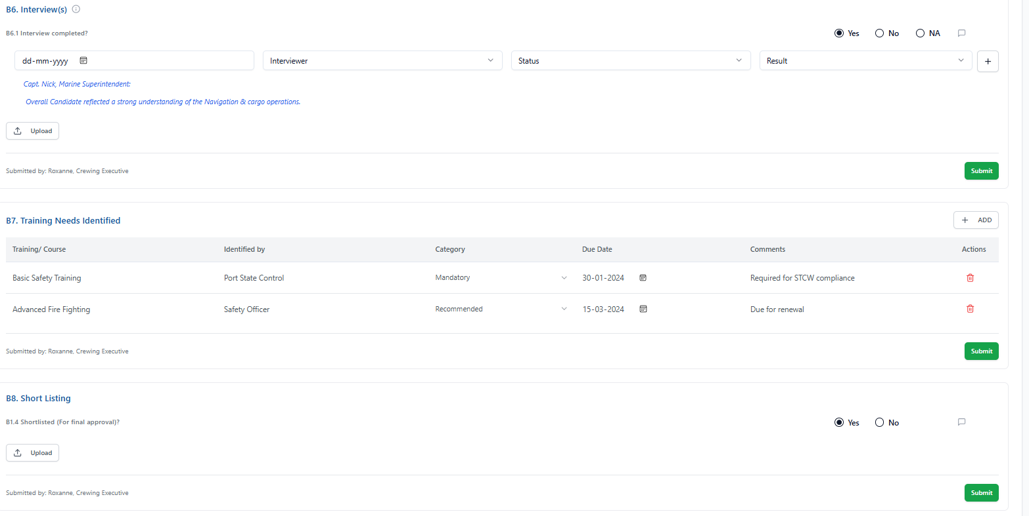

Approval data not saving
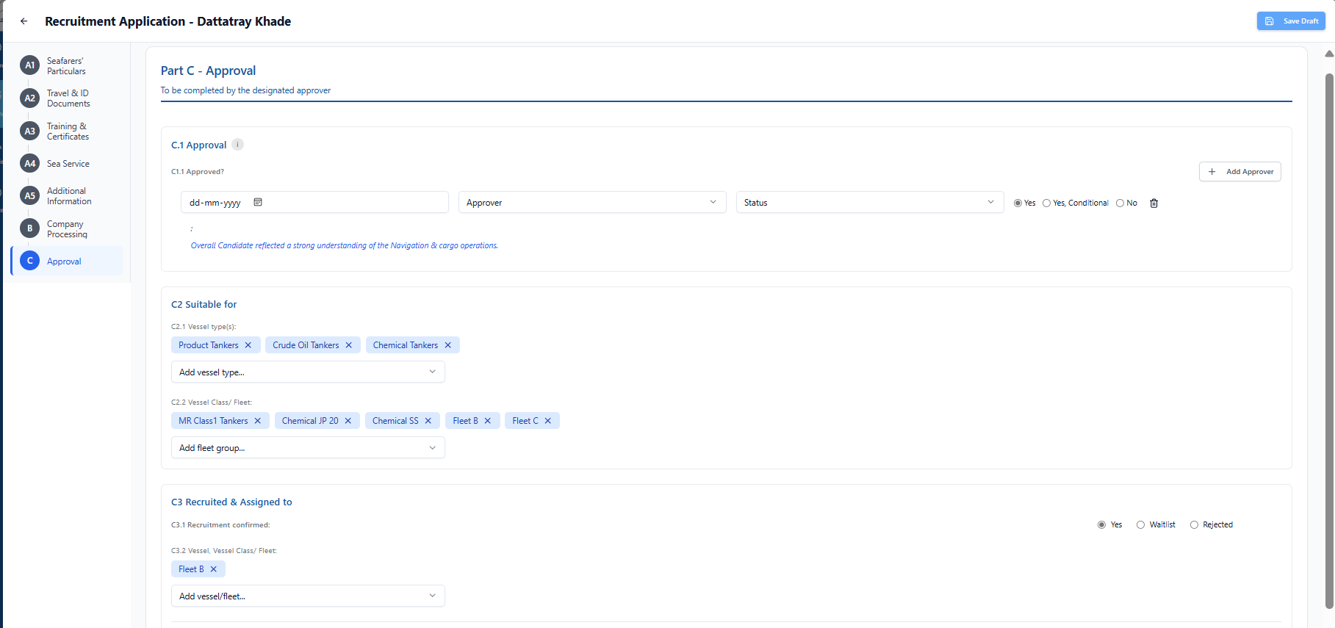

Attachment not bind after saving
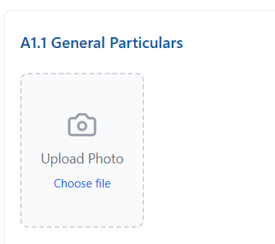
Crew Pool
Filters not working..
E1. Details of Sea Service (Company) period not calculated
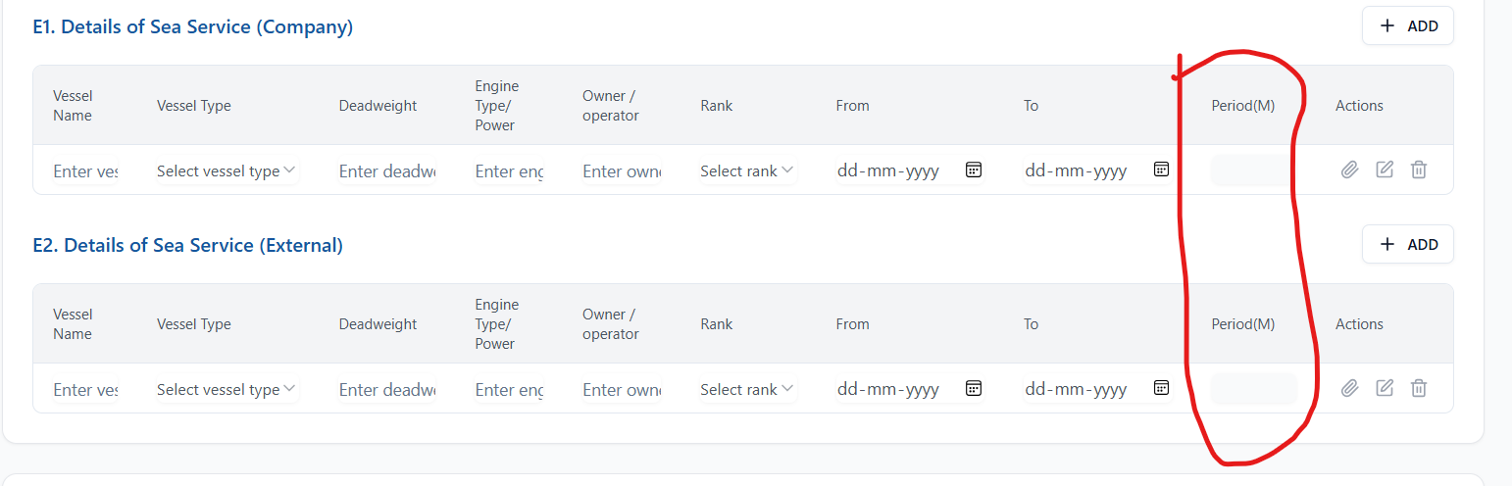

Rotation
Deploy and reject button not working
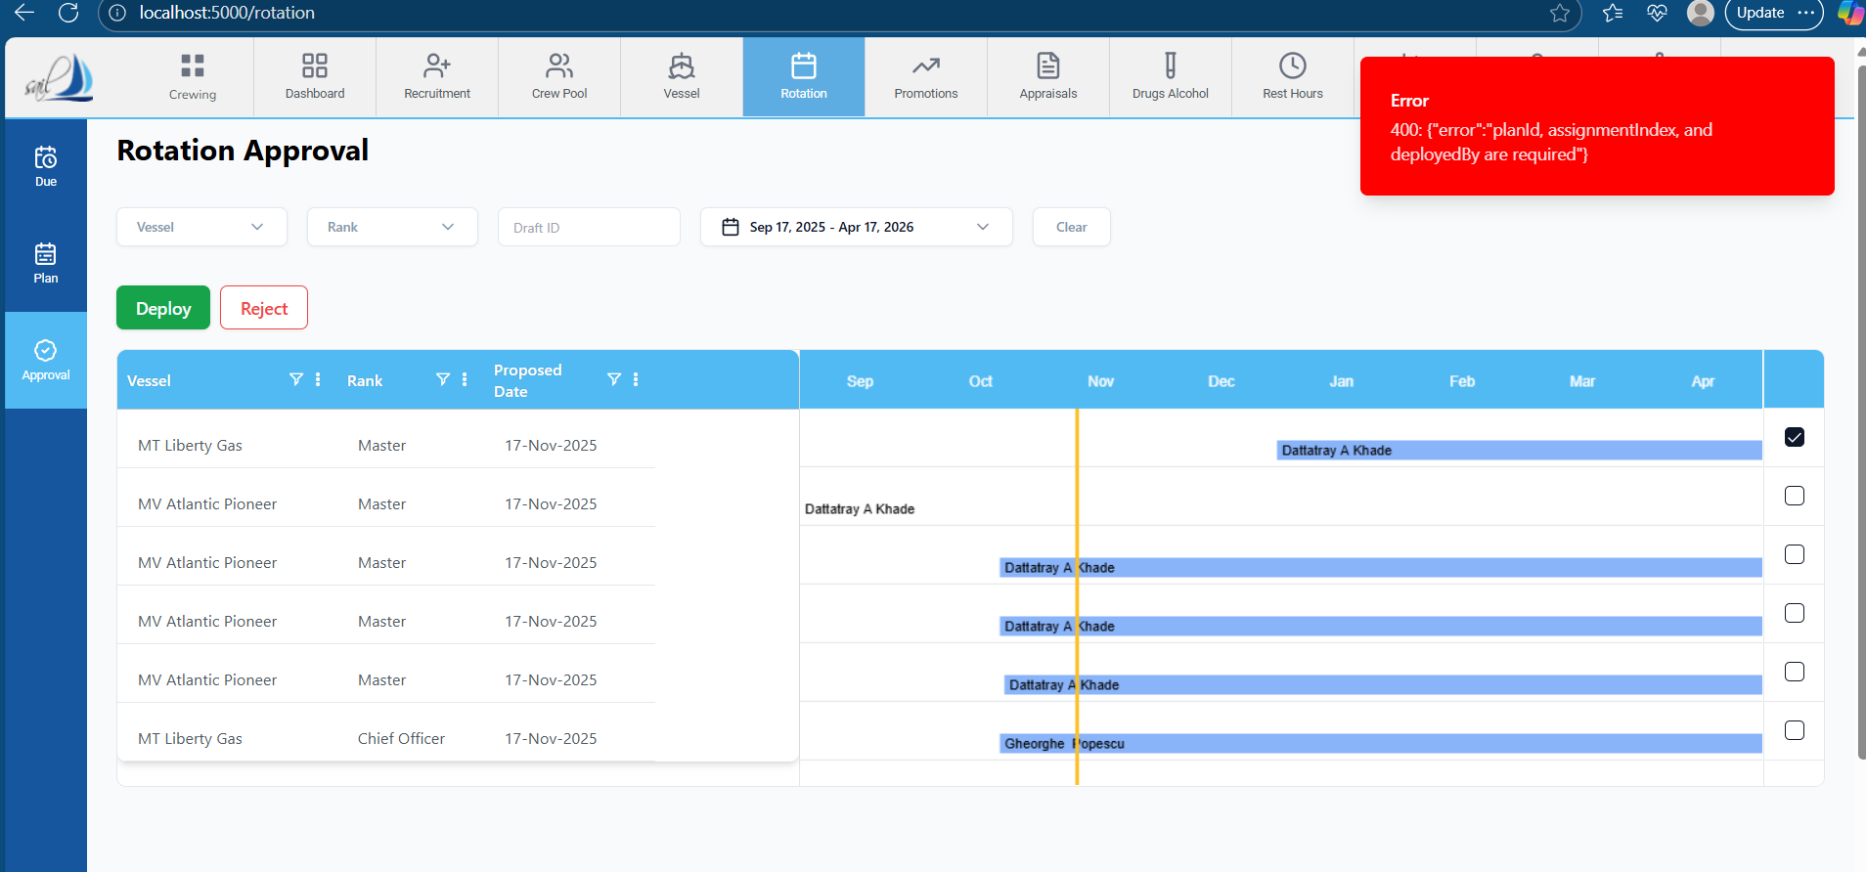

Promotion
form not saving
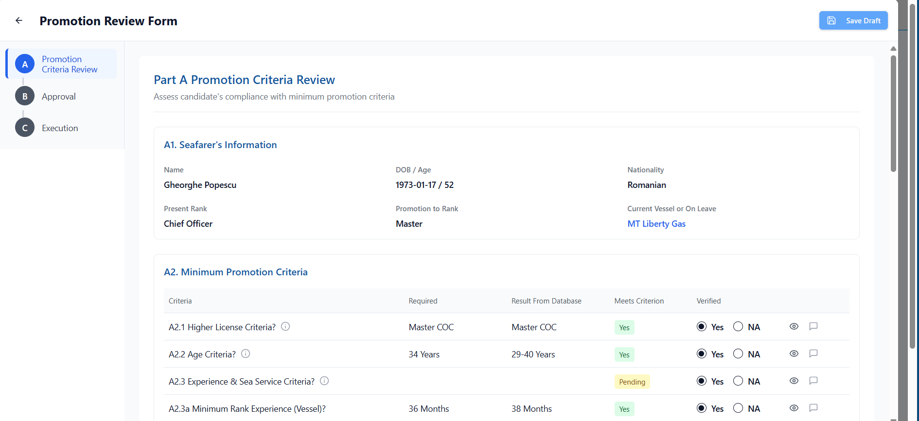

Appraisal
Form not saving
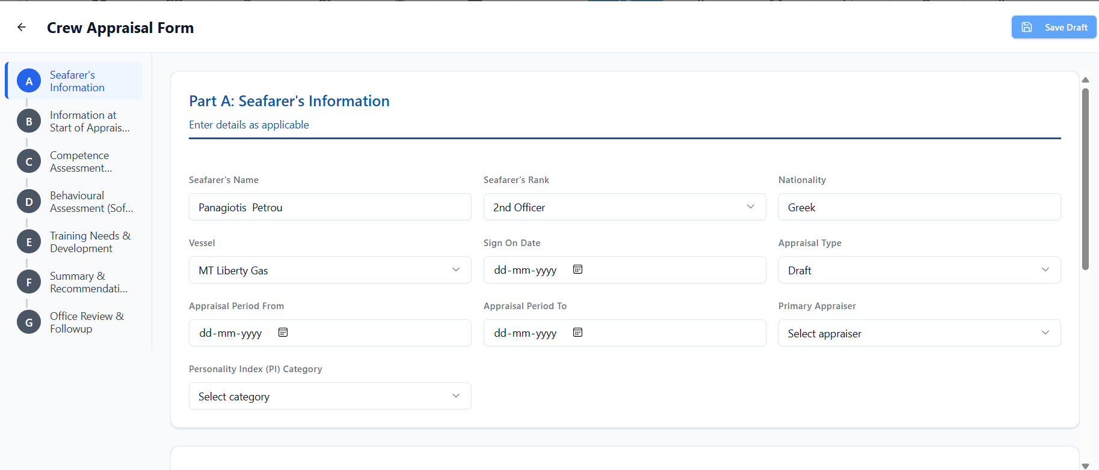

VESSEL
Filter is not working
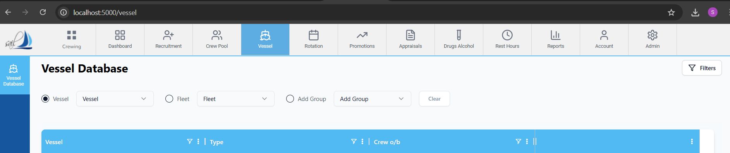

Download button is not working.
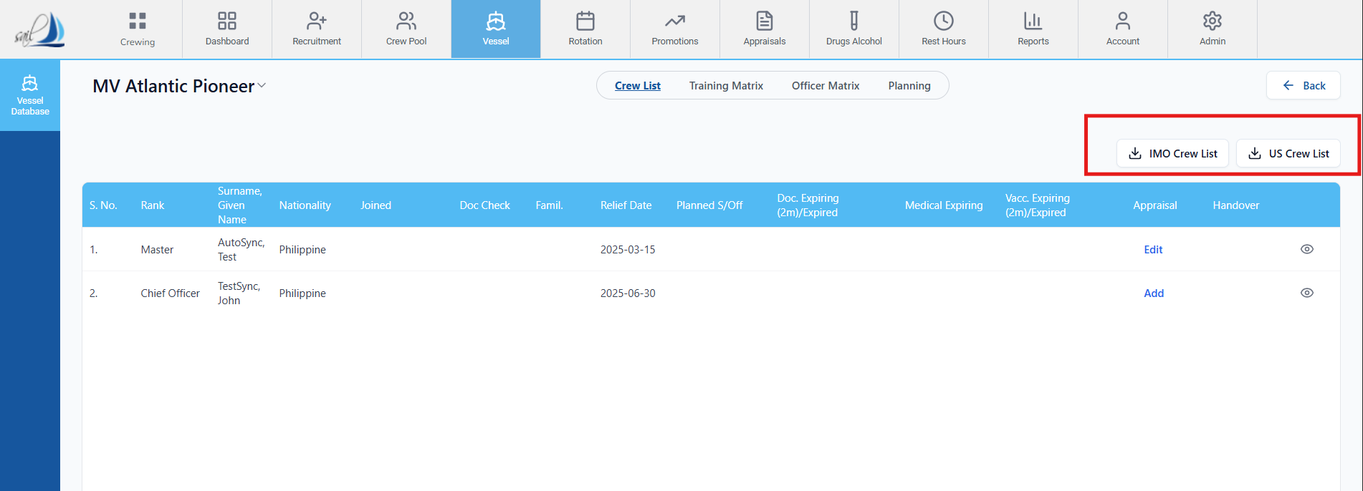

In Office Matrix Eye button inside vessel not working
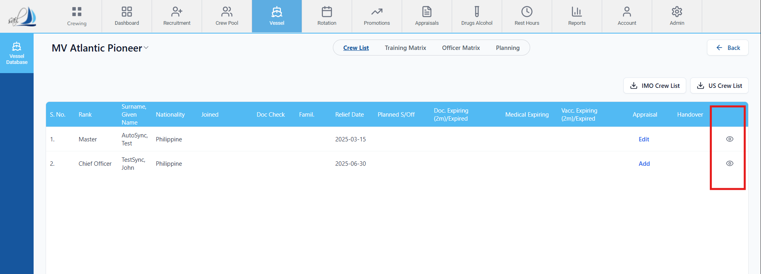
Crew Appraisal Form Save Draft not working.
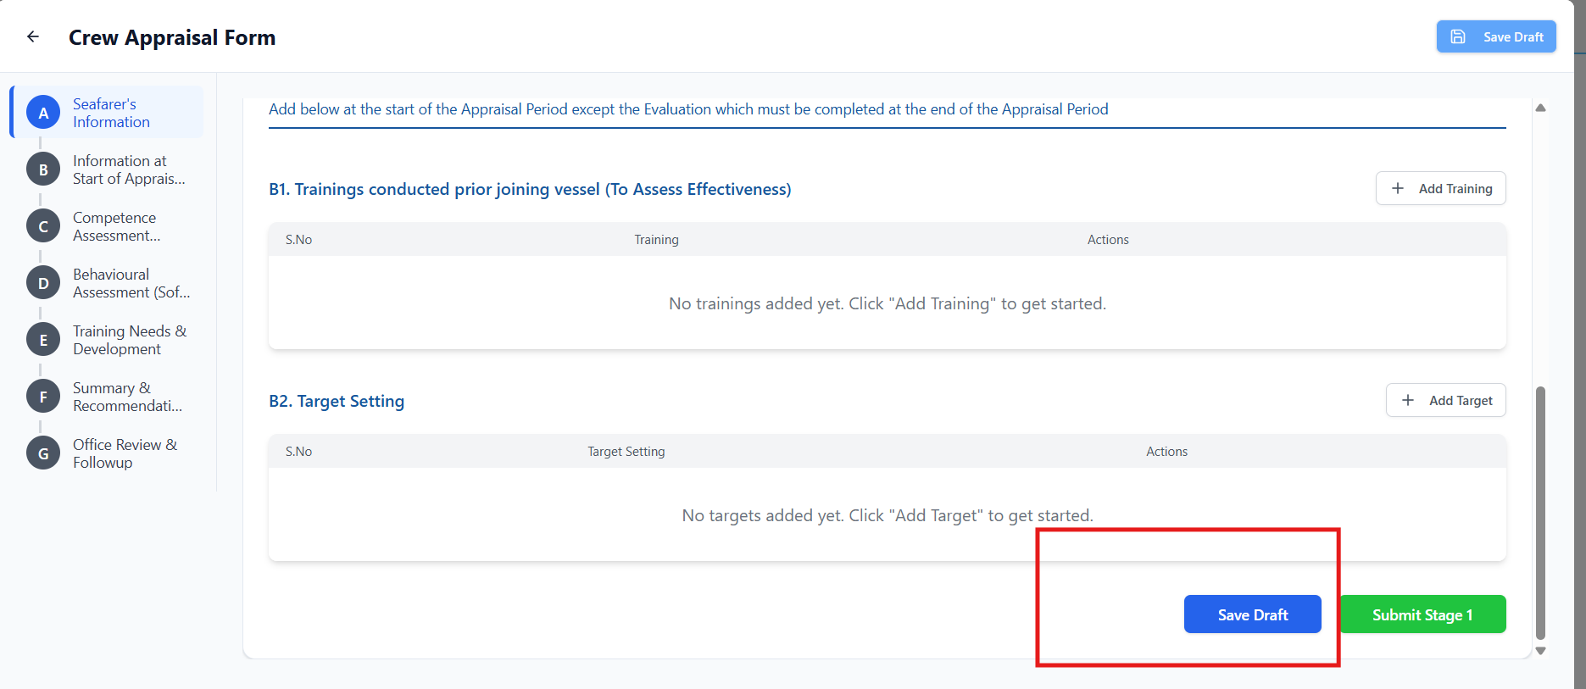

http://localhost:5000/api/forms/for-rank is failing.
Rank: Chief Officer Name,Nationality input field not working
